**Project Report Template**

**Title of Project:** Career path  
**Name of the Innovator:** Punith H  
**Start Date:** 01-09-2025

**End Date: 04-09-2025**

***Day 1: Empathise & Define***

*Step 1: Understanding the Need*

* Which problem am I trying to solve?

The purpose of this project is to **help students and young adults in rural areas get proper career guidance and opportunities** after their studies.

It connects them to **suitable careers, colleges, scholarships, and jobs** through an **AI chatbot**, provides **learning resources** to build their skills, and allows **colleges and employers** to post opportunities — all in one simple platform that **bridges the gap between students and service providers**.

* Who is affected by this problem?
* How did I find out about this? [Select whichever is applicable]
* Interviews
* Observation
* Online Research
* AI Tools

*Step 2: What is the problem?*

The problem is that **students and young adults in rural areas lack proper career guidance, awareness of opportunities, and access to skill-building resources** after completing their studies.

They often don’t know **which career path to choose, which colleges or scholarships to apply for, or how to find suitable jobs**, and there’s **no single platform** that connects them with the right guidance and service providers.

Why is this problem important to solve?

This problem is important to solve because **many talented students in rural areas miss out on good career and education opportunities** simply due to a **lack of guidance and access to information**.

By solving this, we can **help them make informed decisions**, **improve their employability**, and **create equal opportunities** for growth and success, regardless of where they come from.

**Take-home task**

Ask 2-3 people what they think about the project:

* • **Student (recently completed studies in a rural area)**  
  "I think this platform is really helpful — it gives guidance on careers, colleges, and scholarships all in one place."
* • **Career Counsellor / Educator**  
  "The AI chatbot and dashboards make it easy for students to explore options and learn skills, which is very practical for rural students."
* • **Service Provider / College Coordinator**  
  "I like that it allows colleges and training institutes to post opportunities and connect directly with students. It’s a great way to reach the right audience."
* ”

*AI Tools you can use for Step 1 and 2:*

**AI Tools Used:**

**1. Meta MGX**

* **Used as a no-code development tool to design and deploy the *CareerPath* app.**
* **It helps create interactive workflows, user interfaces, and logic without programming.**
* **Ideal for building features like user registration, location-based data, and skill modules.**

**2. ChatGPT**

* **Used for idea generation, content structuring, and chatbot conversation design.**
* **Helped in framing the AI-powered virtual assistant’s responses for guiding students.**
* **Also useful for generating career recommendations, FAQs, and improving user interaction flow.**

**3. Chatbot References (Structure Design):  
To design the AI virtual assistant, you can take reference from:**

* **Google Dialogflow – for understanding intent detection and response flow.**

***Day 2: Ideate***

*Step 3: Brainstorming solutions*

* List **at least 5 different solutions** (wild or realistic):
* **AI Chatbot for Career Guidance** – A virtual assistant that helps students choose the right career and find job opportunities.
* **Skill Learning Website** – A platform to improve communication, aptitude, and soft skills through online lessons.
* **Career Awareness Workshops** – Conducting offline or online sessions in rural schools and colleges to guide students.
* **Mobile App for Scholarship Updates** – Sends alerts about available scholarships and government schemes.
* **Community Mentor Program** – Connects students with mentors or professionals from nearby areas for real guidance.
* **CareerPath Platform** – A complete digital platform combining AI guidance, skill modules, and location-based opportunities built using **Meta MGX**, designed to empower rural youth.

*Step 4: My favourite solution:*

*My favourite solution is* ***CareerPath****, a digital platform designed to empower rural youth. It offers an* ***AI chatbot*** *for personalized career guidance, suggests* ***colleges, scholarships, and jobs****, and includes a* ***callback option*** *for human support. The* ***student dashboard*** *provides skill-building modules, while the* ***service provider dashboard*** *allows colleges and employers to post opportunities dynamically. With* ***location-based personalization*** *and a* ***ready-to-use dummy database****, the app is easy to access, interactive, and a* ***practical, impactful solution*** *for students in rural areas.*

*Step 5: Why am I choosing this solution?*

I’m choosing this solution because it **offers a complete, easy-to-use platform** that addresses all the challenges rural students face — lack of career guidance, limited access to colleges, scholarships, jobs, and skill-building resources.

It combines **AI-powered personalized guidance, learning modules, location-based suggestions, and a service provider dashboard** in one platform, making it **practical, scalable, and impactful**.

*AI Tools you can use for Step 3-5:*

**AI Tools for Step 3–5**

**1. Meta MGX**

* Used to **design and build the CareerPath app** without coding.
* Helps create the **AI assistant, skill modules, and location-based features**.

**2. ChatGPT**

* Helps **brainstorm solutions** and generate ideas for career guidance features.
* Can **structure conversations** for the AI virtual assistant.
* Assists in writing content for skill modules, FAQs, and recommendations.

**4. AI Research Tools**

* **Google Scholar / Research AI** – For exploring existing solutions and innovative ideas for Steps 3–5.
* **AI Text & Summarization Tools** – Helps summarize solutions, select the best approach, and present them clearly.

*AI Tools you can use for the take-home task:*

**Canva AI/CoPilot AI/Meta AI:** Use these mobile-based tools to generate images for the solution they want to design

***Day 3: Prototype & Test***

*Step 6: Prototype – Building my first version*

What will my solution look like?

**My solution’s prototype will be a digital web application with:**

* **An AI chatbot at the bottom-right for personalized career guidance and suggestions.**
* **A student dashboard showing recommended careers, colleges, scholarships, jobs, and learning modules.**
* **A service provider dashboard where colleges, training institutes, and employers can post opportunities.**
* **Location-based features to show nearby colleges and jobs.**
* **Dummy data preloaded so all features work immediately for testing.**
* **Interactive, responsive UI that works on both mobile and desktop, with working downloads and videos.**

**Design Style:**

* Simple, intuitive, and easy to navigate for rural youth.
* Bright and engaging visuals to make learning and exploration fun.
* Mobile-friendly layout for easy access on smartphones.

**Prototype Tools:**

* Built using **Meta MGX**, no coding required, with all features **interactive and testable**.

What AI tools will I need to build this?

**AI Tools Needed to Build CareerPath**

1. **Meta MGX**
   * No-code platform to **design and deploy the app**.
   * Allows building **interactive screens, chat interfaces, and skill modules** without coding.
2. **ChatGPT (or similar LLMs)**
   * To **generate content, conversation flows, and career guidance responses**.
   * Can help **personalize recommendations** for users based on their profile and location.
3. **AI Chatbot Design References**
   * **Google Dialogflow / Microsoft Bot Framework/Hugging face**
   * To **structure conversation logic** and handle user queries effectively.
4. **AI Data Analysis Tools** *(Optional for insights)*
   * **Python AI libraries (Pandas, Scikit-learn)** or **AI analytics platforms**
   * To analyze user interactions and improve recommendations over time.

What AI tools I finally selected to build this solution?

1. **Chat GPT**
2. **Metamgx**

**< Build The Innovation>**

**<DASHBOAD OF THE TOOL>**

**Tool Link:**  <https://careerpathway.mgx.world/>

**Main Dashboard:**

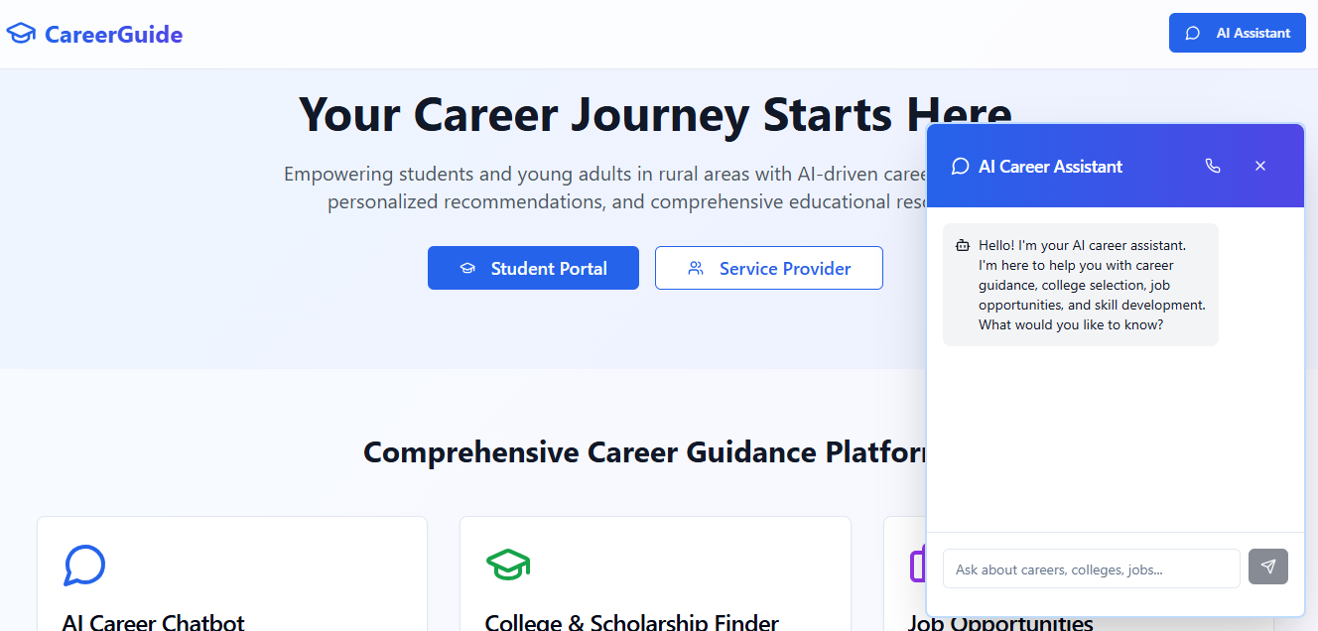

Internal Working of tool:

Student Portal -colleges section:

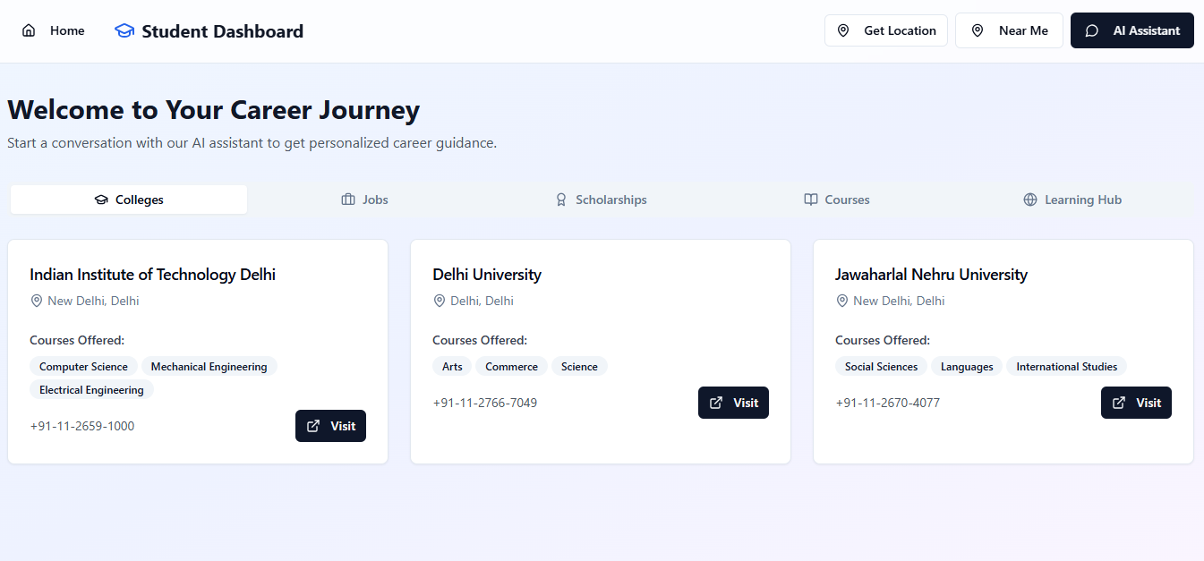

Student Portal -jobs section:  
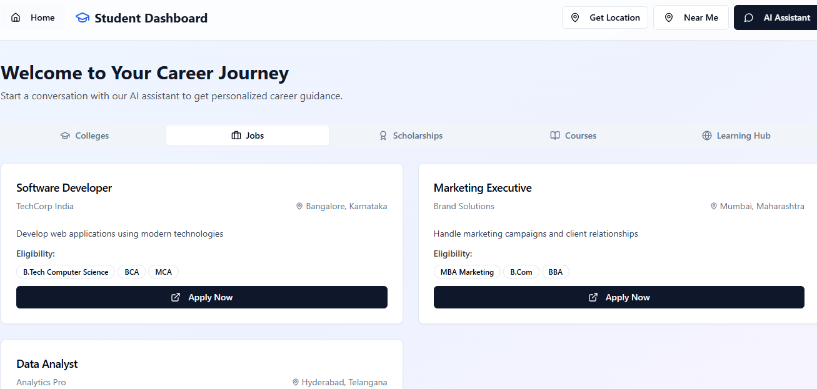

Student Portal -Scholarships section:  
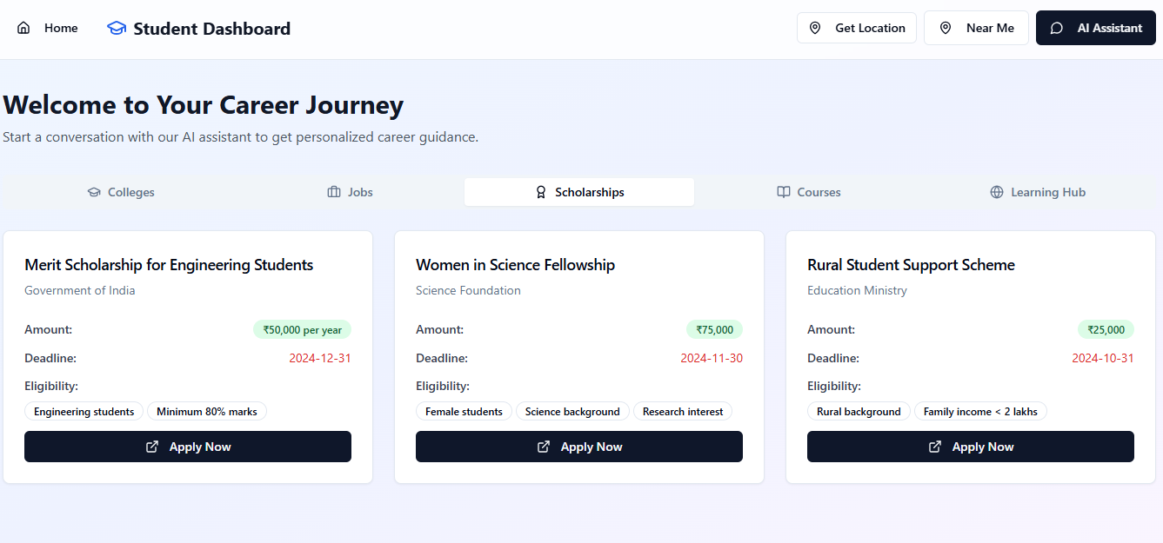  
Student Portal -Course section:

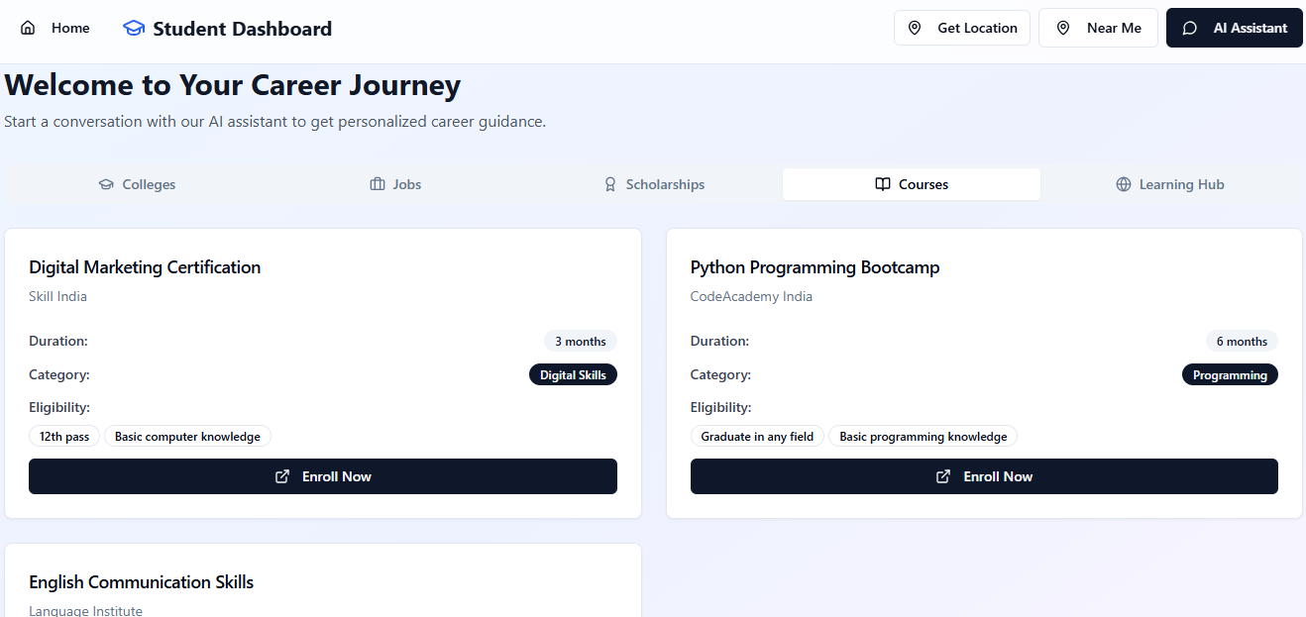

Student Portal-Learning Hub sections

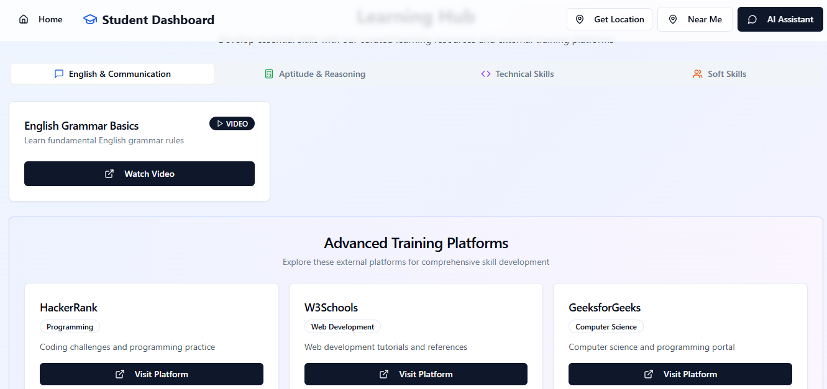

Service Provider dashboard: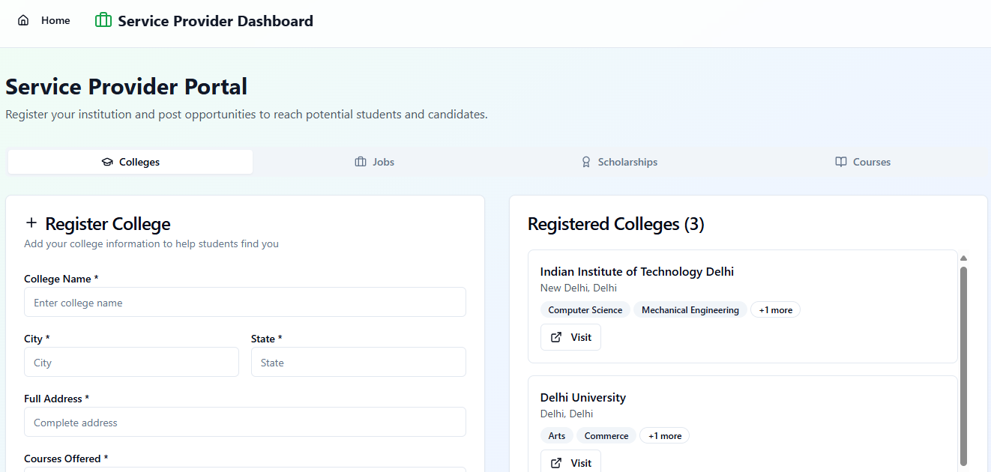

*Step 7: Test – Getting Feedback*

Who did I share my solution with?

I shared my solution with **students, educators/career counselors, and service providers** to get feedback on its usefulness, features, and practical impact for rural youth.

What feedback did I receive?

**Feedback: Pros and Cons**

**The feedback I received was:**

* **The project idea is useful and impactful for rural students.**
* **The AI chatbot and dashboards make guidance easy to access and interactive.**
* **The student dashboard and learning modules are practical and help build skills.**
* **The service provider dashboard is appreciated for connecting students with colleges, training institutes, and employers.**
* **Some technical issues like chatbot overlap were noted, and suggestions were made to add features like callback requests and profile-based tailored alerts.**

**My Response for The Feedback:**  
CareerPath is an idea created using a **no-code tool (Meta MGX)**. As it’s an initial prototype, the resources and integrations are limited. To fully integrate all features and access a wider range of career, scholarship, and skill-building resources, we would need **collaborations with different platforms and organizations**. The current limitations are due to the constraints of the prototype environment, but the concept demonstrates the **potential, usability, and impact** of the platform for rural youth.

👍 What works well:

* The **AI chatbot** provides personalized career guidance and suggestions.
* The **student dashboard** is clear, interactive, and easy to navigate.
* **Service provider dashboard** allows colleges, training institutes, and employers to post opportunities dynamically.
* **Learning modules** with videos and downloadable resources work as intended.
* The platform is **responsive** and works on both mobile and desktop.
* The **prototype demonstrates the core idea effectively**, giving life to the start-up project.

🔧 What needs improvement

* **Chatbot overlap** during conversations needs to be fixed.
* **Interactive features** can be made more dynamic and fully accessible.
* **Profile-based tailoring** can be enhanced so recommendations adapt more accurately.
* **Integration with real databases** and live collaborations with colleges, scholarships, and employers would make the app fully functional.
* **UI/UX enhancements** for smoother navigation and better responsiveness on all devices.

*Tools you can use for Step 6-7:*

**ChatGPT/Perplexity AI/Claude AI/Canva AI/Chatling AI/Figma AI/Metamgx/Gamma AI**: You can use these tools to build solutions/models or mock-up dummy prototypes

***Day 4: Showcase***

*Step 8: Presenting my Innovation:*presenting **CareerPath**, a digital platform designed to guide rural youth in their career, education, and job choices.

Key features include:

* **AI-powered virtual assistant** for personalized guidance on careers, scholarships, and jobs.
* **Student dashboard** with tailored recommendations, learning modules, and skill-building resources.
* **Service provider dashboard** for colleges, training institutes, and employers to post opportunities dynamically.
* **Location-based suggestions** to find nearby colleges, training centers, and jobs.
* **Callback request feature** for human assistance when needed.
* Built as a **prototype using Meta MGX**, with a dummy database to demonstrate dynamic functionality.

This platform **bridges the gap between students and service providers**, making career guidance **accessible, practical, and interactive**.

**<SHOWCASE YOUR INNOVATION TO YOUR PEERS>**

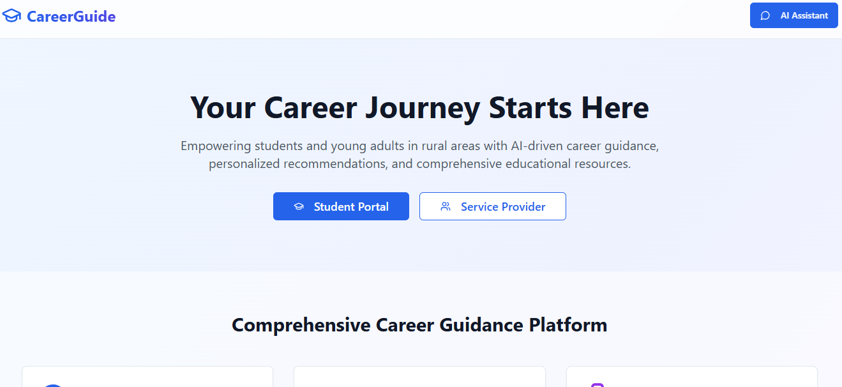

*Step 9: Reflections*

* What did I enjoy the most during this project-based learning activity?

I enjoyed **bringing my business idea to life** and seeing how the AI chatbot, dashboards, and learning modules all work together. It was exciting to **create a platform that can truly help rural youth** explore careers, scholarships, and jobs. I also enjoyed **developing practical features**, like the callback option and profile-based recommendations, to make the app more interactive and user-friendly

What was my biggest challenge during this project-based learning activity?

The biggest challenge was **making the prototype fully functional with limited resources and dummy data**. Integrating the AI chatbot, dynamic dashboards, and location-based features while ensuring smooth interaction was complex. It was also challenging to **simulate real-world functionality** without live databases and external collaborations, but it helped me think creatively to bring the idea to life.

**Take-home task: Uploading in GitHub**

<https://github.com/punithhcreator/Careerpath-No-code-application>